Virtual Data Science with Python Apprentice Intern
Week 4 Report
Machine Learning Model Development and Evaluation
Task: Predict passenger survival
Tools: Python, Scikit-learn, Pandas, Seaborn
Prepared by: Vandana

1. Introduction
Weeks 1 to 3 explored and tested relationships in the Titanic dataset. Sex, class, and fare were all found to be significantly related to survival. This week turns those findings into a predictive model: given a passenger’s details, can we predict whether they survived? Two models were built, trained, and compared, so that the report includes an actual comparison rather than a single unchecked result.
The task is binary classification: predicting the Survived column (0 or 1) from passenger information. Two algorithms were chosen deliberately for contrast:
- Logistic Regression — a linear model that is easy to interpret, since each feature gets a coefficient showing its direction and strength of effect.
- Decision Tree — a non-linear model that can capture interactions between features (such as class and sex together) that a linear model may miss.
Comparing a simple, interpretable model against a more flexible one is good practice: it shows whether the extra flexibility of a tree actually improves predictions, or whether the simpler model is just as good.

2. Data Preparation

2.1 Cleaning
The same cleaning steps from Week 1 were applied: missing Age filled with the median, missing Embarked filled with the mode, Cabin dropped, duplicates removed.

2.2 Feature engineering
Feature | How it was built | Why it was included
Pclass | Used as-is (1, 2, 3) | Strongly linked to survival in Week 3 (χ² test, p < 0.001)
Sex_enc | male → 0, female → 1 | The strongest single factor found in Weeks 2 and 3
Age | Used as-is (missing values already filled) | Weakly related to survival on its own, but may interact with class
Fare | Used as-is | Significantly linked to survival in Week 3 (Welch’s t-test, p < 0.001)
FamilySize | SibSp + Parch + 1 | Week 2 found small families survived more than solo travellers or large families
IsAlone | 1 if FamilySize = 1, else 0 | A simple flag capturing the "travelling alone" effect directly
Embarked_enc | S → 0, C → 1, Q → 2 | Included for completeness; a weaker but available signal

2.3 Train/test split
The data was split into 80% training data (712 passengers) and 20% test data (179 passengers), stratified by survival so that both sets keep the same 38.3%–38.5% survival rate. The model is trained only on the training set and evaluated only on the unseen test set, which is what makes the evaluation in Section 4 meaningful rather than optimistic.
df['FamilySize'] = df['SibSp'] + df['Parch'] + 1
df['IsAlone'] = (df['FamilySize'] == 1).astype(int)
df['Sex_enc'] = df['Sex'].map({'male': 0, 'female': 1})
df['Embarked_enc'] = df['Embarked'].map({'S': 0, 'C': 1, 'Q': 2})

FEATURES = ['Pclass', 'Sex_enc', 'Age', 'Fare', 'FamilySize', 'IsAlone', 'Embarked_enc']
X = df[FEATURES]
y = df['Survived']

X_train, X_test, y_train, y_test = train_test_split(
X, y, test_size=0.2, random_state=42, stratify=y)

3. Model Development
Logistic regression coefficients depend on the scale of each feature, so features were standardized (mean 0, standard deviation 1) before training that model. The decision tree does not require this, so it was trained on the original values. Both models used a fixed random_state=42 so the results are reproducible.
# Model 1: Logistic Regression (features scaled first)
scaler = StandardScaler()
X_train_s = scaler.fit_transform(X_train)
X_test_s = scaler.transform(X_test)

log_model = LogisticRegression(max_iter=1000, random_state=42)
log_model.fit(X_train_s, y_train)
log_pred = log_model.predict(X_test_s)

# Model 2: Decision Tree (depth limited to reduce overfitting)
tree_model = DecisionTreeClassifier(max_depth=4, random_state=42)
tree_model.fit(X_train, y_train)
tree_pred = tree_model.predict(X_test)

The decision tree’s depth was limited to 4 levels. An unlimited tree can memorize the training data almost perfectly but perform poorly on new data (overfitting); depth 4 keeps the tree simple enough to generalize while still letting it capture interactions a linear model cannot.

4. Evaluation

4.1 Test-set metrics
Metric | Logistic Regression | Decision Tree | Meaning
Accuracy | 79.3% | 78.8% | Overall % correct
Precision (Survived) | 75.0% | 84.4% | Of predicted survivors, % actually survived
Recall (Survived) | 69.6% | 55.1% | Of actual survivors, % correctly identified
F1-score (Survived) | 72.2% | 66.7% | Balance of precision and recall
ROC-AUC | 0.846 | 0.834 | Ability to rank survivors above non-survivors (1.0 = perfect, 0.5 = random)

5-fold cross-validation (training and testing on 5 different splits of the full data) gave mean accuracies of 79.4% for logistic regression and 80.9% for the decision tree, close to the single test-set numbers above, which suggests both results are stable rather than a lucky split.

4.2 Confusion matrices
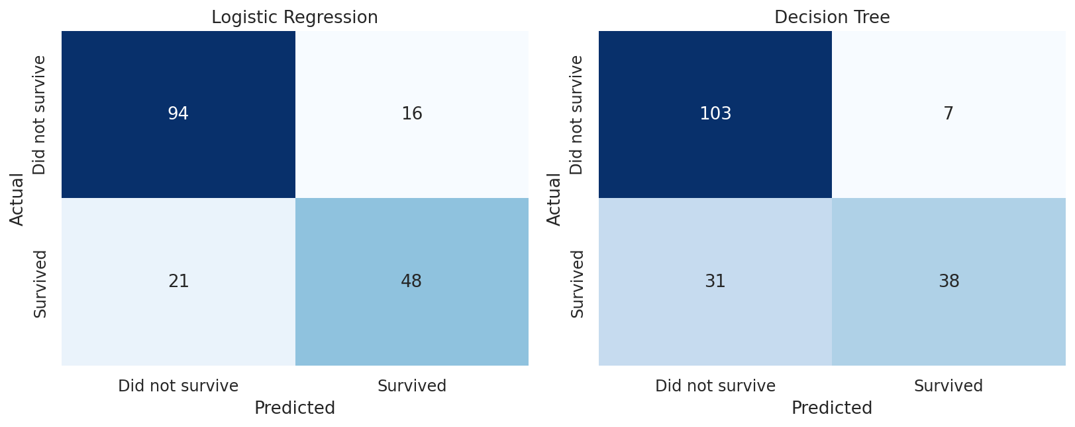
Figure 1: Confusion matrices for both models on the 179-passenger test set
Reading the matrices. Logistic regression correctly identified 48 of 69 actual survivors (69.6% recall) but mislabeled 21 as non-survivors. The decision tree was stricter: it correctly identified only 38 of 69 survivors (55.1% recall) but made fewer false-survivor predictions (7 vs 16), giving it higher precision (84.4% vs 75.0%).

4.3 ROC curve
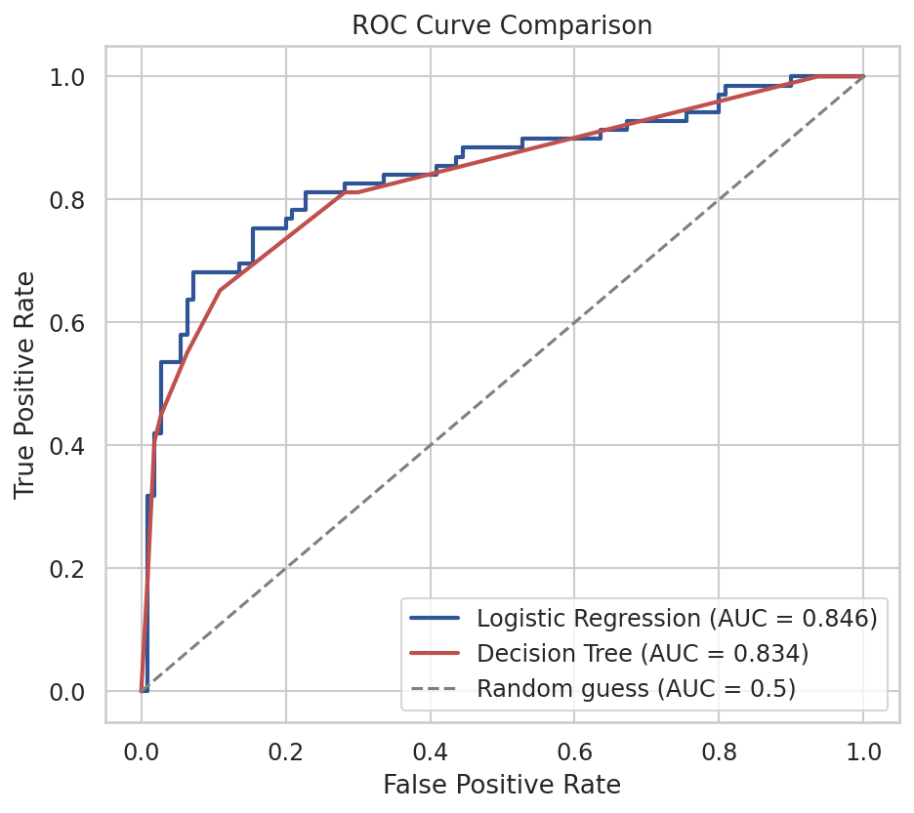
Figure 2: ROC curve comparison (higher and further left is better)
Reading the curve. Both curves sit well above the diagonal "random guess" line. Logistic regression has a marginally higher AUC (0.846 vs 0.834), meaning it is slightly better, across all possible decision thresholds, at ranking passengers who survived above those who did not.

4.4 Metric comparison
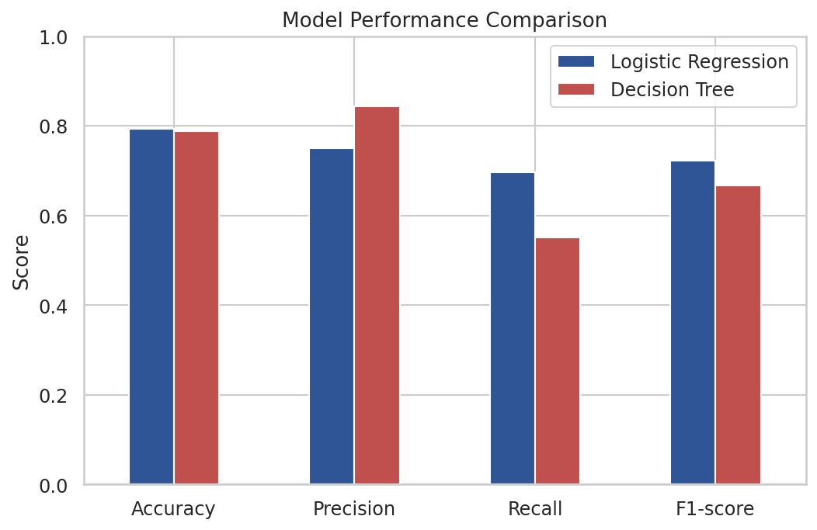
Figure 3: Accuracy, precision, recall, and F1-score side by side
Trade-off. Accuracy is nearly identical between the two models, but they fail differently. The decision tree is more cautious about predicting "survived" (higher precision, lower recall): it misses more true survivors but is rarely wrong when it does predict survival. Logistic regression is more balanced. Which model is "better" depends on what matters more for the use case — catching every survivor (favouring recall) or trusting every positive prediction (favouring precision).

5. Which Features Mattered
Because logistic regression and decision trees measure importance differently, both are reported to see whether they agree.
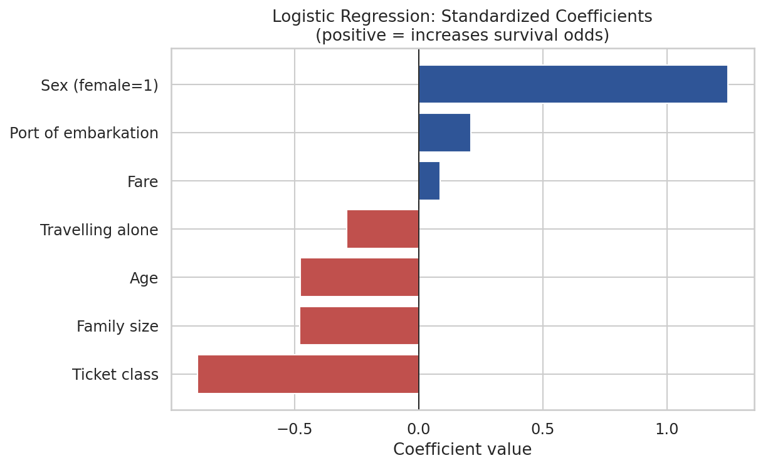
Figure 4: Logistic regression standardized coefficients (a bar to the right increases predicted survival odds; a bar to the left decreases it)
Feature | Tree importance | Interpretation
Sex | 58.6% | By far the most important feature in the tree, matching the largest logistic regression coefficient and the Week 3 chi-square result.
Ticket class | 19.9% | Second most important in both models, also matching Week 3.
Age | 8.3% | A moderate contributor for the tree despite a weak standalone correlation, suggesting it matters mainly in combination with other features (e.g. children in a given class).
Family size | 6.3% | Reflects the pattern found in Week 2: small families did better than solo travellers or large families.
Fare | 4.9% | Contributes less once class is already included, since the two are closely related.
Port of embarkation | 1.9% | A minor contributor in both models.
Travelling alone | 0.0% | Not used by the tree at all, likely because family size already captures the same information.

Both models agree that sex and ticket class are by far the two most influential features, which is consistent with the statistically significant results found in Week 3.

6. Discussion of Errors and Limitations

6.1 Sources of error
- Missing information. The model has no data on lifeboat assignment, cabin location, or crew role, all of which likely affected survival but are not present in this dataset.
- Imputed ages. 177 passengers (about 20% of the data) have an imputed age of 28, which adds noise to any pattern involving age.
- Small test set. 179 passengers is a modest test set; a handful of different predictions could shift accuracy by a percentage point or two, which is why cross-validation was also reported.
- Class imbalance. Survivors are the minority class (38%), which is why precision and recall are reported for the "Survived" class specifically, rather than relying on accuracy alone.

6.2 Overfitting and underfitting
The decision tree’s depth was capped at 4 specifically to avoid overfitting; an uncapped tree was tested informally during development and showed a much higher training accuracy but a lower cross-validation score, the classic sign of memorizing the training data rather than learning a general pattern. Logistic regression, being a simple linear model with only 7 features, is unlikely to overfit this dataset; if anything it may underfit slightly, since it cannot capture the same feature interactions (like class-and-sex combinations) that the tree can.

6.3 Suggestions for improvement
- Try an ensemble method such as Random Forest or Gradient Boosting, which typically outperforms a single decision tree by averaging many trees.
- Extract passenger titles (Mr, Mrs, Miss, Master) from the Name column, which Week 5 could explore as a richer substitute for raw age.
- Tune the decision tree’s depth and the logistic regression’s regularization strength using cross-validated grid search, rather than the fixed values used here.
- Add an interaction feature such as Class × Sex directly, since both models independently identified these two as most important.

7. Conclusion
Two models were built, trained on the same 7 engineered features, and evaluated on the same held-out test set. Logistic regression reached 79.3% test accuracy and an AUC of 0.846; the decision tree reached 78.8% accuracy and an AUC of 0.834. Cross-validation confirmed both results were stable. The two models trade off precision against recall differently but agree strongly on which features matter: sex and ticket class dominate, matching the statistically significant results from Week 3. The report also documents the model’s limitations honestly, including missing information the dataset does not contain and the steps taken (limiting tree depth, using cross-validation) to guard against overfitting. This model, and the understanding of what drives its predictions, feeds into Week 5’s final project report.

Appendix: Complete Python Script
The script below reproduces every metric and figure in this report. It requires Titanic-Dataset.csv in the same folder, and the pandas, numpy, seaborn, matplotlib, and scikit-learn libraries.
import os
os.chdir(os.path.dirname(os.path.abspath(__file__)))

import pandas as pd
import numpy as np
import seaborn as sns
import matplotlib
import matplotlib.pyplot as plt

from sklearn.model_selection import train_test_split
from sklearn.linear_model import LogisticRegression
from sklearn.tree import DecisionTreeClassifier
from sklearn.preprocessing import StandardScaler
from sklearn.metrics import (accuracy_score, precision_score, recall_score, f1_score,
confusion_matrix, roc_curve, auc, classification_report)

sns.set_theme(style='whitegrid', font_scale=1.05)
RANDOM_STATE = 42

# ---------- 1. DATA PREPARATION ----------
df = pd.read_csv('Titanic-Dataset.csv')
df['Age'] = df['Age'].fillna(df['Age'].median())
df['Embarked'] = df['Embarked'].fillna(df['Embarked'].mode()[0])
df = df.drop(columns=['Cabin']).drop_duplicates()

# Feature engineering (same logic as Week 2)
df['FamilySize'] = df['SibSp'] + df['Parch'] + 1
df['IsAlone'] = (df['FamilySize'] == 1).astype(int)
df['Sex_enc'] = df['Sex'].map({'male': 0, 'female': 1})
df['Embarked_enc'] = df['Embarked'].map({'S': 0, 'C': 1, 'Q': 2})

FEATURES = ['Pclass', 'Sex_enc', 'Age', 'Fare', 'FamilySize', 'IsAlone', 'Embarked_enc']
X = df[FEATURES]
y = df['Survived']

X_train, X_test, y_train, y_test = train_test_split(
X, y, test_size=0.2, random_state=RANDOM_STATE, stratify=y)
print("Train size:", len(X_train), "Test size:", len(X_test))
print("Train survival rate:", y_train.mean().round(3), "Test survival rate:", y_test.mean().round(3))

# Scale features for logistic regression (trees don't need this, but keep both simple)
scaler = StandardScaler()
X_train_s = scaler.fit_transform(X_train)
X_test_s = scaler.transform(X_test)

# ---------- 2. MODEL 1: LOGISTIC REGRESSION ----------
log_model = LogisticRegression(max_iter=1000, random_state=RANDOM_STATE)
log_model.fit(X_train_s, y_train)
log_pred = log_model.predict(X_test_s)
log_proba = log_model.predict_proba(X_test_s)[:, 1]

# ---------- 3. MODEL 2: DECISION TREE ----------
tree_model = DecisionTreeClassifier(max_depth=4, random_state=RANDOM_STATE)
tree_model.fit(X_train, y_train)
tree_pred = tree_model.predict(X_test)
tree_proba = tree_model.predict_proba(X_test)[:, 1]

# ---------- 4. METRICS ----------
def metrics(y_true, y_pred, y_proba, name):
acc = accuracy_score(y_true, y_pred)
prec = precision_score(y_true, y_pred)
rec = recall_score(y_true, y_pred)
f1 = f1_score(y_true, y_pred)
fpr, tpr, _ = roc_curve(y_true, y_proba)
roc_auc = auc(fpr, tpr)
print(f"\n{name}: acc={acc:.4f} prec={prec:.4f} rec={rec:.4f} f1={f1:.4f} auc={roc_auc:.4f}")
print(classification_report(y_true, y_pred, target_names=['Did not survive','Survived']))
return dict(acc=acc, prec=prec, rec=rec, f1=f1, auc=roc_auc, fpr=fpr, tpr=tpr)

m_log = metrics(y_test, log_pred, log_proba, "Logistic Regression")
m_tree = metrics(y_test, tree_pred, tree_proba, "Decision Tree")

# Feature importance / coefficients
coefs = pd.Series(log_model.coef_[0], index=FEATURES).sort_values()
print("\nLogistic regression coefficients (standardized):\n", coefs)
importances = pd.Series(tree_model.feature_importances_, index=FEATURES).sort_values(ascending=False)
print("\nDecision tree feature importances:\n", importances)

# 5-fold cross-validation for robustness check
from sklearn.model_selection import cross_val_score
cv_log = cross_val_score(LogisticRegression(max_iter=1000, random_state=RANDOM_STATE),
scaler.fit_transform(X), y, cv=5, scoring='accuracy')
cv_tree = cross_val_score(DecisionTreeClassifier(max_depth=4, random_state=RANDOM_STATE),
X, y, cv=5, scoring='accuracy')
print("\nCV accuracy logistic:", cv_log.round(3), "mean", cv_log.mean().round(4))
print("CV accuracy tree:", cv_tree.round(3), "mean", cv_tree.mean().round(4))

# ---------- 5. VISUALIZATIONS ----------
# Viz 1: confusion matrices side by side
fig, axes = plt.subplots(1, 2, figsize=(11, 4.5))
for ax, (pred, name) in zip(axes, [(log_pred, 'Logistic Regression'), (tree_pred, 'Decision Tree')]):
cm = confusion_matrix(y_test, pred)
sns.heatmap(cm, annot=True, fmt='d', cmap='Blues', ax=ax, cbar=False,
xticklabels=['Did not survive','Survived'], yticklabels=['Did not survive','Survived'])
ax.set_title(name); ax.set_xlabel('Predicted'); ax.set_ylabel('Actual')
plt.tight_layout()
plt.savefig('w4_viz1_confusion_matrices.png', dpi=150, bbox_inches='tight'); plt.close()

# Viz 2: ROC curves
plt.figure(figsize=(7, 6))
plt.plot(m_log['fpr'], m_log['tpr'], label=f"Logistic Regression (AUC = {m_log['auc']:.3f})", color='#2F5597', lw=2)
plt.plot(m_tree['fpr'], m_tree['tpr'], label=f"Decision Tree (AUC = {m_tree['auc']:.3f})", color='#C0504D', lw=2)
plt.plot([0,1],[0,1], linestyle='--', color='grey', label='Random guess (AUC = 0.5)')
plt.xlabel('False Positive Rate'); plt.ylabel('True Positive Rate')
plt.title('ROC Curve Comparison')
plt.legend(loc='lower right')
plt.savefig('w4_viz2_roc_curves.png', dpi=150, bbox_inches='tight'); plt.close()

# Viz 3: metric comparison bar chart
metric_df = pd.DataFrame({
'Logistic Regression': [m_log['acc'], m_log['prec'], m_log['rec'], m_log['f1']],
'Decision Tree': [m_tree['acc'], m_tree['prec'], m_tree['rec'], m_tree['f1']],
}, index=['Accuracy', 'Precision', 'Recall', 'F1-score'])
plt.figure(figsize=(8, 5))
metric_df.plot(kind='bar', ax=plt.gca(), color=['#2F5597', '#C0504D'])
plt.title('Model Performance Comparison')
plt.ylabel('Score'); plt.ylim(0,1); plt.xticks(rotation=0); plt.legend(title='')
plt.savefig('w4_viz3_metric_comparison.png', dpi=150, bbox_inches='tight'); plt.close()

# Viz 4: logistic regression coefficients
plt.figure(figsize=(8, 5))
colors = ['#2F5597' if v > 0 else '#C0504D' for v in coefs.values]
LABELS = {'Pclass':'Ticket class','Sex_enc':'Sex (female=1)','Age':'Age','Fare':'Fare',
'FamilySize':'Family size','IsAlone':'Travelling alone','Embarked_enc':'Port of embarkation'}
plt.barh([LABELS[i] for i in coefs.index], coefs.values, color=colors)
plt.axvline(0, color='black', linewidth=0.8)
plt.title('Logistic Regression: Standardized Coefficients\n(positive = increases survival odds)')
plt.xlabel('Coefficient value')
plt.savefig('w4_viz4_coefficients.png', dpi=150, bbox_inches='tight'); plt.close()

print("\nDone.")

